

**DOCUMENTATION OF E-PROJECT**

**Acknowledgement**

***Warm Welcome to Our Website***

We are delighted to welcome you to our website, which is a part of my first-semester project at Aptech Gulshan, developed under the guidance of Sir Ali Baig. This project shows my learning journey and incorporates a variety of technologies including HTML, CSS, JavaScript, AOS library, Swiper.js, Animate.css, and Wow.js. We hope you enjoy exploring our website and find it informative and engaging.

**Submitted By : Sir Ali Baig.**

**Students : Muhammad Zahid.**

**Muhammad Sajid.**

**Shehryar Affandi.**

INTRODUCTION

**Zara’s Therapy**

*Welcome to a World of Holistic Healing*

Zara’s Therapy offers a sanctuary for those seeking professional care and holistic healing. Our team of highly skilled therapists is dedicated to providing exceptional services tailored to meet the unique needs of each individual. From massage therapy to acupuncture, physical rehabilitation to aromatherapy, we offer a range of services aimed at promoting well-being and restoring balance.

**Our Mission**

Our mission is to provide the highest quality care and support to our clients on their journey to optimal health and wellness. We believe in the power of holistic healing and strive to create a nurturing environment where healing can flourish.

**Why Choose Zara’s Therapy?**

- **Experienced Professionals**: Our therapists are certified and licensed professionals with years of clinical experience.

- Personalized Care: We offer personalized treatment plans tailored to meet the specific needs of each client.

- **Comprehensive Services**: From massage therapy to acupuncture, we offer a wide range of services to address various health concerns.

- **Compassionate Approach**: We provide compassionate and empathetic care to support our clients on their healing journey.

**Contact Us**

For more information about our services or to schedule an appointment, please contact us at contact@therapy.com or call us at 0029129102320. Visit our website at [www.zaratherapy.com] to learn more about our services and therapists.

**Follow Us**

Stay connected with us on social media for the latest updates and wellness tips. Follow us on [Facebook], [Twitter], [Instagram], and [LinkedIn].

At Zara’s Therapy, your well-being is our priority. Experience the healing power of holistic therapy and embark on a journey to a healthier, happier you.

**Hardware/ Software Requirements**

**Hardware**

* A minimum computer system that will help you access all the tools in the courses is a Pentium 166 or better
* 64 Megabytes of RAM or better

**Software *[Either or Combination as per Course/Sem]***

* Notepad/HTML editor/CoffeeCup
* Angular / Angular JS / React / BootStrap
* Dreamweaver / Figma
* MS IE / Chrome / FireFox / Netscape /MS Edge

**Problem Statement**

Zara’s Therapy Clinic specializes in providing relief from stress, improving relaxation, enhancing circulation, and alleviating pain through muscle and tissue manipulation. Their therapists also aid in injury rehabilitation and overall wellness.

The clinic recognizes the importance of having a strong online presence, particularly through a well-designed website, to attract new clients and expand their practice. A website serves as a crucial platform for showcasing services, engaging with potential clients, and establishing credibility in the digital space.

**Requirement Specification**

The website for Zara’s Therapy Clinic needs to meet the following requirements:

1. **Home Page**: The home page should feature sections with a suitable logo and images of therapies or demo sessions to engage visitors.

2. **Navigation Links**: The site must have clear navigation links to help users easily access different categories of information.

3. **Menu**: A menu should be included to provide a brief introduction about the therapists available, contact details, and other relevant information.

4. **Products and Services**: The site should include a list of related products and services, such as essential oils, lotions, and therapy accessories.

5. **Service Categorization**: Services should be categorized based on technique, medical aid, beauty aids, etc., for easy browsing.

6. **Additional Sections**:

- **Gallery**: High-quality images to enhance the website's visual appeal and showcase products or services.

- **Client Testimonials/Reviews**: Text and video testimonials to build trust and credibility.

- **About Us Page**: Information about the clinic and its team to establish credibility.

7. **Contact Us Page**: This page should include the clinic's address displayed using Geo-Location API (e.g., Google Maps) and an email address that links to the local mail client for inquiries.

8. **Appointment Page**: This page should allow users to schedule appointments online. It should include a form where users can select their preferred date, time, and type of therapy they are interested in. The form should also collect basic contact information such as name, email, and phone number.

9. **Doctors/Therapists Page**: This page should provide detailed information about the therapists available at the clinic. Each therapist's profile should include their name, photo, qualifications, specialties, and years of experience. This page can help potential clients learn more about the therapists and choose the one that best suits their needs.

**Conclusion:**

A well-designed website for Zara Therapy Clinic will not only enhance their online presence but also help them attract new clients and establish themselves as a reputable therapy clinic. By incorporating the above requirements, the website can effectively showcase their services, engage with potential clients, and ultimately drive business growth.

**CODE VIEW**

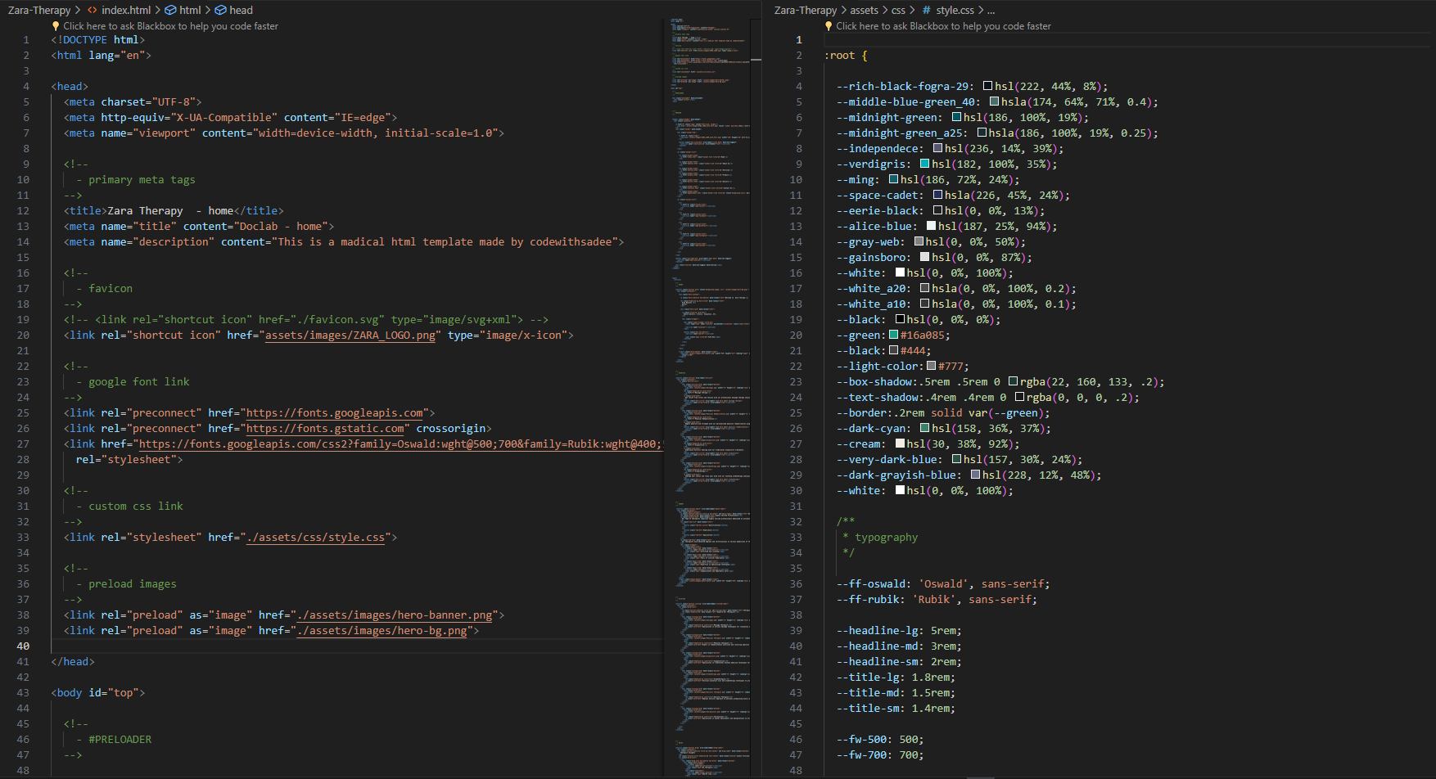

**HOME PAGE**

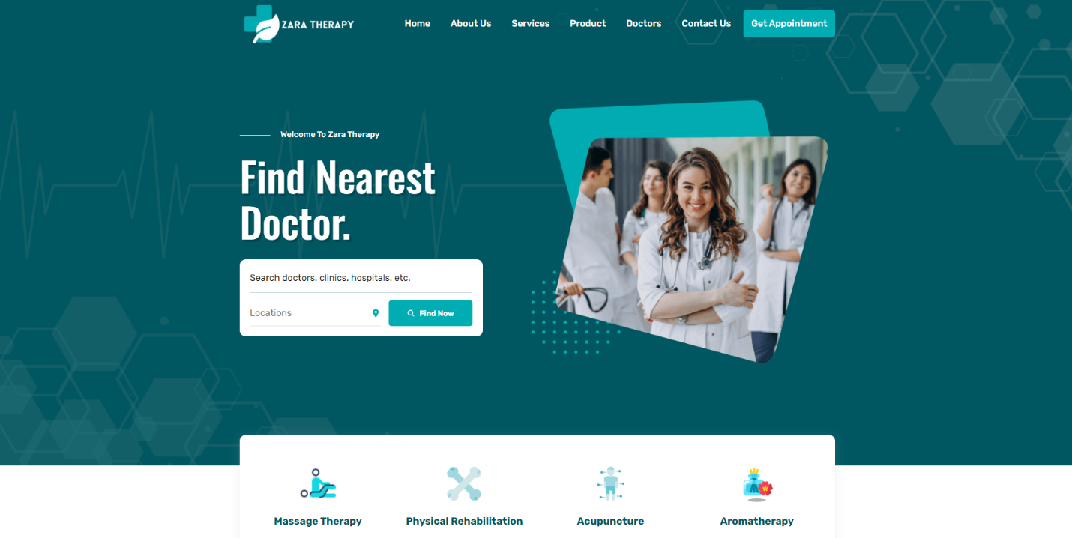

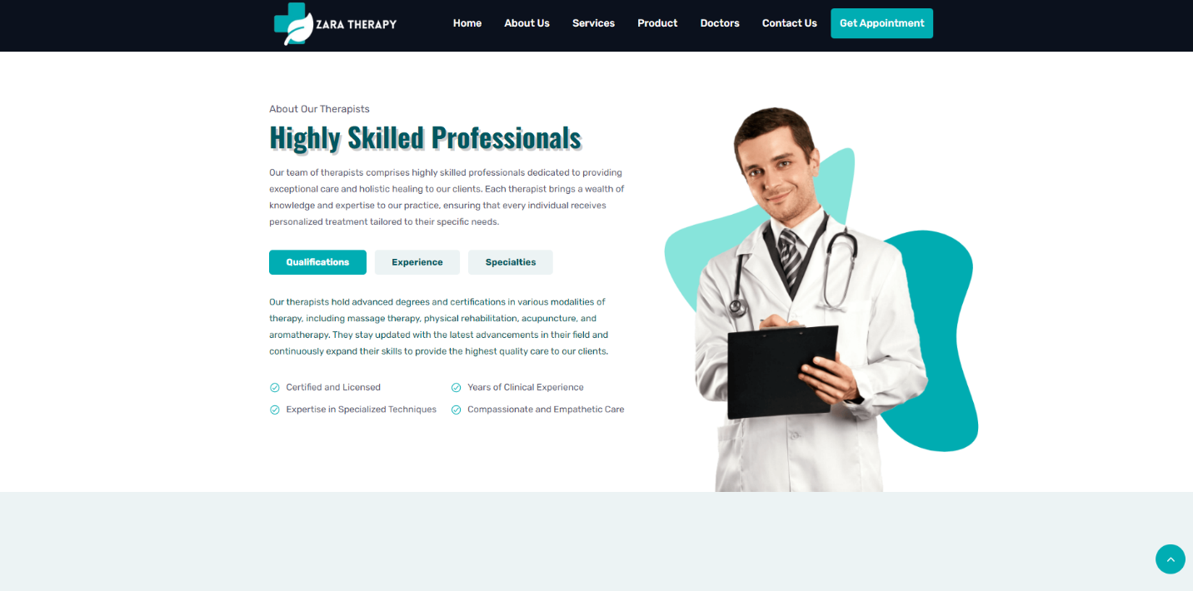

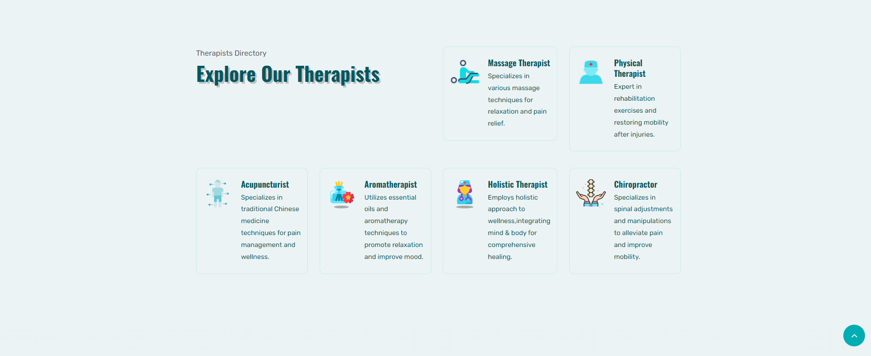

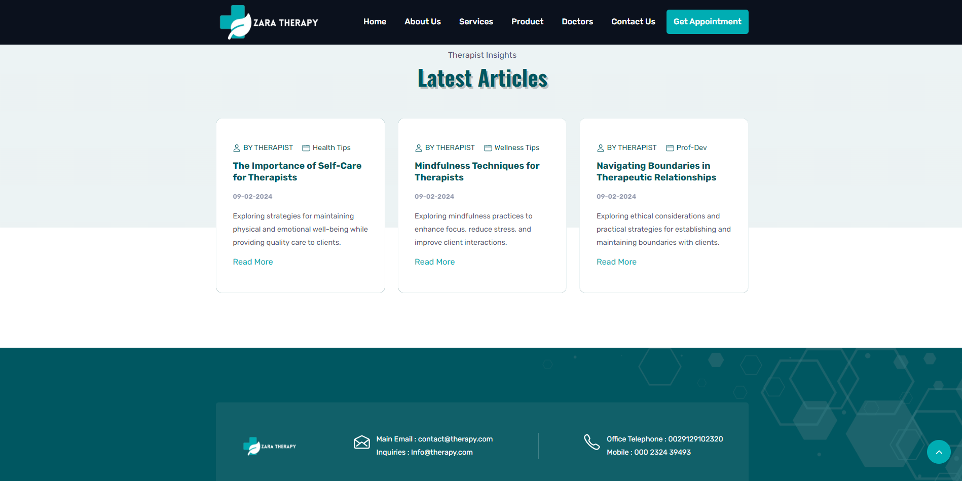

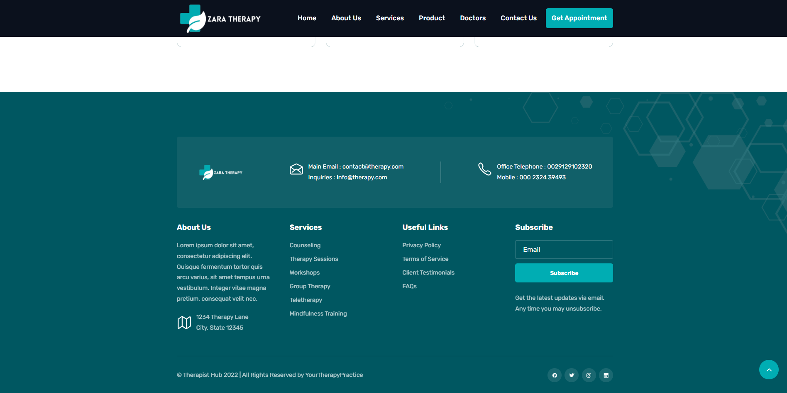

**NOTE:**

The complete website is available on GitHub, where I deployed it using Netlify. You can view the entire codebase and the deployed site on GitHub.

GitHub Account : https://github.com/zahidrahimoon